## Consultation date:

The purpose of this case history form is to identify and collect relevant data regarding the behaviour problem(s) in order to develop a relevant behaviour modification plan. The form will take approximately 30 minutes to fill out and will be received by Anna Kodíček, who will be in contact about arranging an appointment.

All information obtained from this form will be held by Click Clop and may be used to inform other behavioural cases carried out by Click Clop. This will not include your personal information, nor the horse’s, to maintain anonymity.

Veterinary referral is preferred prior to consulting the behaviour problem(s) present in order to rule out any underlying pain or medical condition that could be causing or contributing to the behaviour.

I hereby give my consent to Click Clop to contact my horse’s registered veterinarian to discuss the horse’s medical history and details regarding the case if it is deemed appropriate.

Signed: Date:

If you do not wish Click Clop to contact your veterinarian, please sign below.

I understand that refusal for Click Clop to contact my horse’s veterinarian may hinder progress and could result in the termination of any training.

Signed: Date:

*If you require additional information please contact Anna Kodíček via email:*

*Click-clop@outlook.com*

Please look over the whole form and fill out as much information as you can in as much detail as possible. Don’t feel the need to fill out the form in one sitting. Please return the filled out form 24 hours prior to a scheduled consultation.

### Owner Information

Please complete with your and the yard’s information:

| Your full name: | Vet name: |
| --- | --- |
| Your mobile number: | Vet number: |
| Yard name: | Vet email: |
| Yard postcode: |  |

Are you okay with me contacting your Veterinarian listed, or any other paraprofessionals (e.g. farrier, trainer, dentist) you discuss through this case history? (If yes please provide their contact details)

| Veterinarian | Farrier | Dentist |
| --- | --- | --- |
| Trainer | Physiotherapist | Other |

If other please list below:

Are you okay with videos and photos being taken of your horse?

* Yes
* No

Are you okay with videos and photos being stored and used for presentations, webinars or demonstrations?

* Yes
* No

All instances where you are present in the image/video will be blurred to maintain anonymity and confidentiality.

What is your highest level of equine qualification? E.g. BHS stage 3

Answer here…

How many years approximately have you worked with horses?

Answer here…

How long have you owned this horse roughly?

Answer here…

If comfortable, please answer the following questions relating to disability. These are not required or mandatory questions and further prompting will not be made unless stated otherwise by the responder.

Do you have any access requirements you would like me to be aware of?

Do you or any other handlers of the horse have any disabilities you would like to disclose?

### Understanding current disability by handlers or owners will benefit the formation of further training and potentially improve dissemination of information.

### General Horse Information

Please complete with the horse’s information:

| Name: | Age: |
| --- | --- |
| Breed: | Sex: |

How many owners has the horse had?

Answer here…

How many people are currently working with the horse?

Answer here…

What is the horse currently being trained for? E.g. dressage, show jumping etc.

Answer here…

What has the horse been trained for in the past?

Answer here…

Has your horse competed in the past?

Answer here…

Does your horse have a disability such as blindness, deafness or a neurological condition?

Answer here…

How would you describe your horse’s personality?

Answer here…

On a scale of 1-5 (1 being very poor and 5 being very good), how well does your horse respond to the following:

| Tacking-up | Untacking | Rugging | Leading |
| --- | --- | --- | --- |
| Riding in the school | Hacking | Riding on the road | Lunging |
| Catching from field | Catching from stable | Stabling | Turning out |
| Being given hay | Being given hard fed | Feeding from hand | Picking up feet |

How much does your horse weigh (if you have access to a weighbridge)?

Answer here…

How tall is your horse?

Answer here…

How would you estimate your horse’s body condition score? Please circle the score on the following page that best suits your horse.

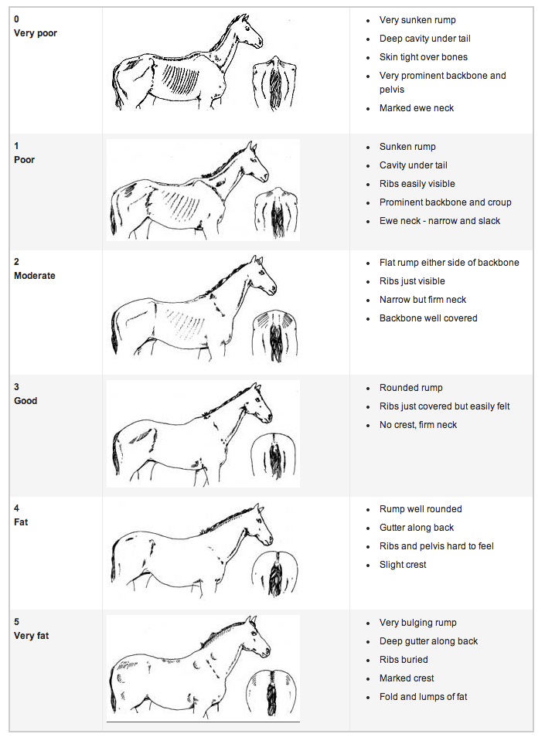

### 

### Horse Behaviour

Please describe the behaviour that prompted you to contact a behaviour consultant? Use as much detail as you can about the behaviour.

Answer here…

What times and/or places do they display this behaviour most frequently?

Answer here…

When did you first notice the behaviour?

Answer here…

Is the behaviour consistent?

* Yes
* No

If No, how does the behaviour differ over time and/ or location?

Answer here…

What is the current management surrounding the behaviour? E.g. your horse pulls to the field so they are no longer turned out

Answer here…

Have you contacted anyone before to work on this specific behaviour problem?

* Yes
* No

If Yes, what did they do with the horse, and what was the outcome from the intervention? E.g. trainer (name) lunged them twice a day for a week and (the behaviour) became less intense

Answer here…

Are there any additional behaviours you are concerned with?

Answer here…

Have they previously been treated for a different behaviour problem?

* Yes
* No

If Yes, what was the behaviour, how was it treated, and did it resolve?

Answer here…

Does your horse perform any stereotypies (stable vices such as weaving or box walking)?

* Yes
* No

If yes, please list the stereotypy(s):

Answer here…

What is your end goal for the behaviour problem?

Answer here…

How much time can you commit to working with the horse specifically on the behaviour problem?

Answer here…

### Feeding

Do they get hay, haylage, alfalfa, or another type of forage?

Answer here…

When during the day do they get their forage?

Answer here…

How much forage do they get (by section, by weight, or by other means)

Answer here…

Do they get hard feed?

* Yes
* No

If yes, how many times a day do they get hard feed and at what times?

Answer here…

What feed brand(s) do you use and which products of theirs?

Answer here…

What weight, Stubb scoop volume, or estimate of each feed do you use?

Answer here…

Does your horse receive any supplements in their feed?

* Yes
* No

If yes, please list the supplements:

Answer here…

### 

### Turnout and stabling

If they are stabled, what stable design do you use? Example: individual box, barn, shared box

Answer here…

What size is the stable in feet or metres?

Answer here…

What bedding do you use?

* Straw
* Shavings
* Woodchips
* Paper
* Other

If other please state the bedding used:

Answer here…

What bedding management style do you use? E.g. deep litter, daily muck out, mucked out every 3 days

Answer here…

How often do they receive turnout?

* Constant
* Daily
* Twice a week
* Once a week
* Fortnightly
* Once a Month
* Less than once a Month
* Never

How long are they turned out for roughly (if seasonal choose the duration of the current season)? Leave blank if answer for previous question was “constant” or “never”

* 30 minutes
* 1 hour
* 2 hours
* 3+ hours
* During the day
* Overnight

What type of turnout is it?

* Group
* Individual
* Track system/ paddock paradise
* My horse does not receive turnout

If in a group, are they always the same group, and how many are together?

Answer here…

What size in feet, acres, or metres is the field/ track?

Answer here…

Are they on livery?

* Yes
* No

If yes, what type of livery?

Answer here…

### Riding, tack and training

How often do they get ridden typically?

* Every day once
* Every day 2-4 times
* Every day 5+ times
* Every week once
* Every week 2-4 times
* Every week 5+ times
* Every month once
* Every month 2-4 times
* Every month 5+ times
* They are not ridden

What intensity would you describe the exercise?

| Low - e.g. rarely come out of trot | Medium - e.g. frequently canter, some jumping | Hard - e.g. fast canter and gallop regularly |
| --- | --- | --- |
|  |  |  |

How would you describe your horse’s behaviour when ridden?

Answer here…

When was their saddle last checked for fitting?

Answer here…

What bridle style do they have? E.g. grackle

Answer here…

If they have a bit, what style is it?

Answer here…

What tack does your horse wear when out hacking?

Answer here…

What tack does your horse wear when schooling? If the same as above please write: as above.

Answer here…

What style of training do you typically use? You can tick more than one.

* Positive punishment - e.g. Use of the whip
* Negative punishment - e.g. Removal of food or water
* Positive reinforcement - e.g. Use of food rewards
* Negative reinforcement - e.g. Pressure-release

Please list in the empty space below the equipment and tools you normally use during training and riding:

Answer here…

### Medical

Has your horse experienced a traumatic event in the past? E.g. falling from height, trailer falling over, being punched or hit with an object other than a whip

Answer here…

Has your horse had any serious medical conditions or injuries? E.g. Gastric ulcers, colic, broke a bone etc.

* Yes
* No

If Yes, when did they develop/ occur and how were they treated?

Answer here…

Does your horse have any current medical conditions or injuries and how long have they had them? E.g. Laminitis, equine metabolic syndrome

Answer here…

Is your horse on any prescribed medication?

* Yes
* No

If Yes please list the medications:

Answer here…

When was their last worming treatment?

Answer here…

When was their last Farrier/ trimmer visit?

Answer here…

Do they have an orthopaedic issue that is currently being treated with remedial shoeing?

* Yes
* No

When was their last Vet check?

Answer here…

Was this routine or about the behaviour problem?

Answer here…

What were the vet's notes about the horse after the check?

Answer here…

When were your horse’s teeth last checked?

Answer here…

What were the dentist's notes about the horse after the check?

Answer here…

Have you contacted anybody else about the behaviour problem? E.g. Chiropractor, veterinary physiotherapist, nutritionist etc.

Answer here…

### Additional space